The decomposition and emission factors of dioxins, PAHs and PCBs in diverse, contaminated organic waste fractions undergoing dry pyrolysis

*Katinka M. Krahn1, Erlend Sørmo2,3, Gudny Øyre Flatabø4, Hans Peter H. Arp3,5, Gerard Cornelissen2,3*

1) Lindum AS, 3036 Drammen, Norway

2) Norwegian University of Life Sciences (NMBU), 1430 Ås, Norway

3) Norwegian Geotechnical Institute (NGI), 0484 Oslo, Norway

4) Scanship AS, Nedre Langgate 19, 3126, Tønsberg, Norway

5) Norwegian University of Science and Technology (NTNU), 7491 Trondheim, Norway

*Corresponding author contact details: gerard.cornelissen@ngi.no

### Keywords:

Pyrolysis, sewage sludge, organic waste, legacy pollutants, dioxins, PAHs, PCBs, biochar, emission factors, mass balance

### Graphical Abstract

Abstract

Emission concentrations, emission factors, total concentrations in feedstock and biochar at different temperatures are provided for PAH, TCDD/Fs and PCBs. Seven feedstocks were tested: waste timber, garden waste, limed sludge, digested sludge, food waste reject, pyrolyzed at temperatures between 500-800 ˚C in a pilot-scale dry pyrolysis plant, slow. Pyrolysis eliminated TCDD/F and PCBs in feedstocks, however, PAHs were formed, but below EBC guidelines some of them.

# Introduction

Organic pollutants are ubiquitous in the environment. There are many pollutants in waste from synthetic chemical addition to products and they leach and end up in wastewater. Persistent organic pollutants (POPs) are problematic due to their persistence, bioaccumulation, and toxicity in the environment. Find ways to safely treat waste that contains problematic compounds. Elevated concentrations in humans of dioxins and PCBs, long-term effects.

Polychlorinated dibenzo p-dioxins and dibenzofurans (PCDD/Fs), commonly referred to as dioxins, are a group of planar tricyclic aromatic compounds that form non-intentionally during the production of chlorinated compounds or during combustion processes. Dioxins are carcinogenic and potent.

* + 8 homologue groups according to the numbers of chlorine atoms present

Polychlorinated biphenyls (PCBs) are non-planar

* + Commercial production began in 1929 by chlorination of biphenyl, 10 available positions for chlorination
  + Commercial utility of PCBs:
    - Strong chemical and physical stability
    - Electrical resistance
    - Low volatility
    - Resistance to degradation at high temperatures
* Polycyclic aromatic hydrocarbons (PAH)
  + Carcinogens/mutagens
  + Product of incomplete combustion
* Organic pollutants in sewage sludge, mobility and accumulation
* Agricultural use of sludge
* Treatment methods, issues with combustion PAHs, derivatives.

the studies on the effect of

sludge pyrolysis on the removal of other than PAH organic pollutants are scarce. Regarding

* Municipal waste incineration, standard at >1000 degrees as waste handling strategy for dealing with hazardous contaminated waste streams. Modern waste incinerators are equipped with scrubbers to remove potentially contaminated particles from the exhaust
* Use of sewage sludge soil application but restricted due to contents of organic pollutants, nutrient enrichment: ban on direct sewage sludge soil application
  + STRUBIAS report: sewage sludge banned from the list of prohibited EU fertilizing products and also banned as feedstock to produce pyrolysis and gasification materials in 2019 due to lack of data on fate or organic pollutants (Moško et al., 2021) started to close this knowledge gap.
  + STUBIAS report is hesitant about pyrolysis and gasification being a treatment method for removal of organic pollutants(Huygens et al., 2019). But largely based on hydrothermal carbonization (HTC) which is conducted at low-temperature (180-250 ˚C).
* Pyrolysis is a potentially sustainable way to treat sewage sludge, especially for sludges with a low content of heavy metals.
  + Relation between temperature and PAH content, difference to leaching.

Sørmo 2020 pyreg:

The European Biochar Certificate specifies contaminant threshold

levels in biochar for agricultural soil improvement (EBC, 2012). These

threshold levels are all based on total content in the solid phase. Meanwhile,

to give an accurate assessment of risk, bioavailable concentrations

* should be considered (Reichenberg and Mayer, 2006).

Moško et al. (2021) addressed the knowledge gap on the lack of data on the fate of organic pollutants (PAHs, PCBs, PPCPs) and heavy metals, during pyrolysis. Mosko studied removal of organic pollutants and heavy metals during pyrolysis of sewage sludge in lab-scale experiments. This study does the same but in pilot scale and analyzesall pyrolysis products (exhaust, oil and biochar). Recent work by (Sørmo et al., n.d.) released the first decomposition data and emission factors for PFAS compounds from waste fractions during pyrolysis. In this study, the same waste feedstocks were studied for dioxins, PCBs and PAHs using the same pyrolysis reactor.

# Materials and methods

## Chemicals and materials

Whatman® Glass fiber filters (GFF) and 153 Amberlite® XAD-2® were acquired from Merck (Darmstadt, Germany), what about PUF?

## Contaminated organic waste fractions

### Waste fraction descriptions

Seven contaminated waste materials, and one reference material (CWC), were investigated in this study (Table 1). The waste materials included four sludge-based feedstocks (DSS-1, DSS-2, and LSS), one reject from biogas production from food waste (FWR), and two wood-based feedstocks (GW and WT). Based on literature, the waste fractions investigated were all expected to contain different dioxins and PCBs, as well as some PAHs, however, the PAHs were expected to form during thermal treatment.

### Bulk sampling and pre-treatment before pyrolysis

Each feedstock was subsampled, dried and pelletized (length 40 mm, radius 8 mm) before pyrolysis according to the methods described in Sørmo et al., (n.d.).

Table 1. Description of the waste material feedstocks studied, conditions for their respective pyrolysis treatments, and sampling information.

|  |  |  |  |  |  |  |
| --- | --- | --- | --- | --- | --- | --- |
| **Feedstock** | **Abbrev.** | **Description** | **Pyrolysis temperatures (˚C)** | **Pyrolysis residence time (min)** | **Solid phases sampled** | **Flue gas sampled** |
| Digested sewage sludge | DSS-1 | Sewage sludge and food waste pre-treated with thermal hydrolysis (170 ˚C) followed by anaerobic digestion for biogas production | 500, 600, 700 and 750 | 20 | Yes | Yes (except 750 ˚C) |
| Digested sewage sludge | DSS-2 | Sewage sludge treated by anaerobic digestion for biogas production | 500, 600, 700 and 800 | 20 | Yes | Yes |
| Limed sewage sludge | LSS | Sewage sludge treated by anaerobic digestion for biogas production, then stabilized/hygenized by addition of lime (39%) | 600 and 700 | 20 | Yes | Yes |
| Food waste reject from biogas production | FWR | The rejected fraction of food waste before biogas production. Consists of material that does not pass the initial sieving process that removes plastics and other items that are too large or non-digestible | 600 and 800 | 20 | Yes | Yes |
| Garden waste | GW | Gardening waste from private housholds and businesses. Fraction includes twigs, leaves, roots and some sand/gravel | 500, 600 and 800 | 20 | Yes | Yes (500 and 800 ˚C) |
| Waste timber | WT | Discarded wood products and objects from private housholds, businesses and construction/demolition (no chemically impregnated wood) | 500, 600, 700 and 800 | 20 | Yes | Yes |
| Wood chips | CWC | Pellets produced from pine and spruce wood chips from forestry/logging | 500, 600, 700 and 750 | 20 | Yes | No |

## Pyrolysis

The feedstock pellets were pyrolyzed using a medium scale Biogreen® pyrolysis unit (2-10 kg biochar/hr) built by ETIA Ecotechnologies using the technology and operational conditions (temperatures and residence times, Table 1) specified in Sørmo et al., (n.d.). The pyrolysis gas was channeled into a condenser unit where pyrolysis oil was collected through a liquid lock while the syngas was led further to a combustion chamber where it was combusted with propane at 800-900 ˚C before being released as exhaust through a chimney. Gas emission measurements and samples were collected from the chimney during stable temperature conditions.

## Sampling and emission measurements

### Solids sampling

Solids sampling and sample preparation (feedstock, biochar, and oil) were conducted according to the procedures described in Sørmo et al., (n.d.). Samples ready for chemical characterization consisted of feedstock pellets, dried and crushed (D < 1 mm) biochar and pyrolysis oil that was vigorously shaken to homogenize the oil and water phase. Biochar samples were characterized for all pyrolysis treatments (Table 1). Pyrolysis oil was characterized only for CWC and DSS-1-600, 700 and 800 ˚C.

Biochar yields (Ybiochar %) at each treatment temperature were obtained from the Sørmo et al., (n.d.) study, where Ybiochar % was defined as the rate of biochar produced divided by the feedstock feeding rate over the time period with stable conditions.

### Gas emission sampling

Exhaust gas and aerosols were sampled according to the procedure described in Sørmo et al., (n.d.). Gas measurements were collected for sewage sludge feedstocks, except for CWC (all treatments), DSS-1 (750 ˚C treatment), and GW (600 ˚C treatment). A glass fiber filter (GFF) was used for aerosol collection (0.45 µm), followed by an XAD-2 sorbent for gas phase contaminants from the sludge-based feedstocks, and a PUF sorbent for the wood-based feedstocks.

## Sample preparation and instrumental analysis

### PAH, dioxin, and PCB analysis

PAH, dioxin, and PCB extraction methods.

## Quality control and assurance

Procedural blanks for PUF, XAD and GFF were taken to analyze background contamination at the pyrolysis plant. PAHs were measured in triplicate and dioxins were analyzed from single measurements. Samples were analyzed in triplicate for feedstocks and biochar, duplicate for GFF, and single measurements for XAD, PUF and pyrolysis oil.

## Data analysis

For statistical analyses, LOQ/2 was used in cases where one or two of the replicate data points were < LOQ.

Removal efficiency (RE):

|  |  |
| --- | --- |
| $$RE \left(\%\right)=100\%-\left(\frac{C_{biochar}*Y_{biochar}}{C_{feedstock}}\right)$$ | (Eq. 1) |

where Cbiochar is the pollutant concentration (ng g-1) in the biochar produced at a given pyrolysis temperature, Cfeedstock is the pollutant concentration (ng g-1) in the feedstock and Ybiochar is the yield (Eq. 1)(Eq. 1) of the biochar in the pyrolysis process. To be conservative, values below LOQ were set equal to LOQ when calculating removal efficiencies.

Emission factor (EF) was calculated using the volume gas sampled per kg biochar (m3 kg-1) that was normalized for propane added to the burner during combustion of the flue gases:

|  |  |
| --- | --- |
| $$EF_{pollutant}=conc_{pollutant}*V_{flue gas}$$ | (Eq. 2) |

# Results and discussion

## Organic pollutants in feedstocks

### Dioxins in feedstock

The total concentration of dioxins (PCDD/F-17) in toxic equivalents (TEQ) in the sludge and food waste reject feedstocks were 1.2±0.1, 1.8±0.1, 3.0±0.1, and 8.3±0.2 ng TEQ kg-1 for FWR, DSS-2, LSS, and DSS-1, respectively. These concentrations were in the lowest range or below the sum PCDD/F-17 found in 36 different Norwegian sewage sludges (range 3-69, median 6 ng TEQ kg-1) (Paulsrud et al., 1997). The distribution of dioxins was similar for the sludge feedstocks and mainly dominated by OCDD (85-91%), followed by 1,2,3,4,6,7,8-HpCDD (6-11%) (Figure S.X). The distribution of dioxins in FWR was dominated by OCDD (80%), 1,2,3,4,6,7,8-HpCDD (9%), and OCDF (9%).

### PCBs in feedstocks

The total concentration of PCB-7 in the four feedstocks analyzed were 7.6 ± 0.6, 9.2 ± 0.4, 16.6 ± 1.0, and 20.7 ± 0.6 µg kg-1 for DSS-2, FWR, LSS, and DSS-1, respectively (Figure S.X). These concentrations were below previously reported findings: range in x WWTPs in x

These concentrations were below the sum PCB-7 found in 36 different Norwegian sewage sludges (range 17-100, median 42 µg kg-1) (Paulsrud et al., 1997). The distribution of PCBs was evenly distributed between the 7 PCBs in DSS1, DSS-2, and FWR, whereas LSS was dominated by PCB52 (60%).

### PAHs in feedstocks

PAHs are generally a product of combustion and was not expected to be present at high concentrations in the feedstocks. However, all 16 PAHs analyzed for were detected in the feedstocks except for in the wood chips (CWC) in concentrations ranging from 0.38 ± 0.01 mg kg-1 in food waste reject (FWR) to 5.05 ± 0.09 mg kg-1 in waste timber (WT) (Figure S.X). These concentrations are in the same range as the lower range of sum PAH-16 found in 36 different Norwegian sewage sludges (range 0.7-30, median 3.9 mg kg-1) (Paulsrud et al., 1997).

## Organic pollutants in biochars

### PCDD/PCDFs in biochars

Concentrations of ∑PCDD/F-17 in the biochar samples ranged between 0.003 ng TEQ kg-1 in DSS-1-800 to 0.07 ng TEQ kg-1 in FWR-600 and were thus 2-3 orders of magnitude lower than in the original feedstocks (details on removal efficiency in section x, table x). There was no significant (p>0.05) linear relationship between reduction in dioxin concentration and pyrolysis temperature. However, for FWR, the concentration of dioxins decreased by one order of magnitude from 600 to 800 ˚C whereas the to other feedstocks (DSS-1 and DSS-2) stayed within the same order of magnitude for all temperatures (except for DSS-1-800 that dropped one order).

Pyrolysis reduced the variety of dioxin congeners – the biochar samples contained 43-86 % (R: congeners) fewer congeners (mean 69 ± 12%, R: congeners_avg) than their feedstock materials (Figure S.X, haven’t made yet). The most persistent dioxins toward thermal degradation was 1,2,3,4,6,7,8-HpCDD which was found in all feedstocks and biochar samples at each temperature. OCDD was found in 90% of the biochars (R: congeners_poll). Overall, the HxCDFs, HxCDDs, PeCDFs and PeCDDs were most easily degraded.

(Hu et al., 2007) found that only 0.000085 pg TEQ g-1 was detected in char from pyrolysis of contaminated sediments at 800 ˚C and a residence time of 30 minutes. This is five to six orders of magnitude lower than the biochar concentrations in this study, however, removal efficiency are still above 99% (see section x). The study proposed that volatilization was the main mechanism of removal for PCDD/Fs

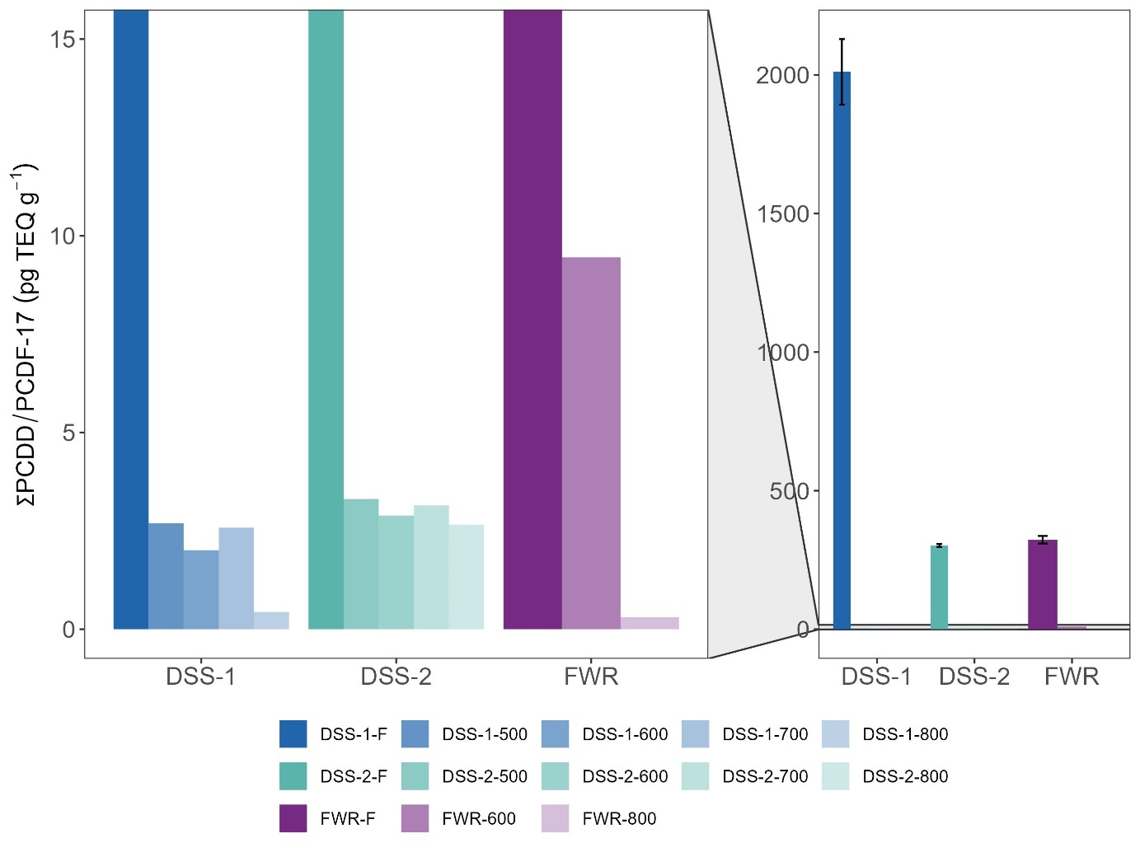

Figure 1 Total PCDD/F concentrations as toxic equivalents (ng TEQ kg-1) before and after pyrolysis treatment at increasing temperatures for the different feedstocks tested.

### PCBs in biochars

Concentrations of ∑PCB-7 in the biochar samples ranged from <LOQ (DSS-1-600) to 1.7 µg kg-1 (DSS-1-500) and were thus 1-2 orders of magnitude lower than in the original feedstocks (details on removal efficiency in Section 3.3, Table 2). All biochar samples were below the European Biochar threshold for premium quality biochar for sum TEQ PCDD/F of <20 ng kg-1 (EBC, 2022). There was no significant (p>0.05) linear relationship between reduction in PCB concentration and pyrolysis temperature. However, for DSS-1, the concentration of PCBs decreased from 500 to 700 to 800 ˚C (<LOQ at 600 ˚C). The other feedstocks (DSS-2 and LSS) were within the same order of magnitude for all temperatures.

Pyrolysis reduced the variety of PCB congeners – the biochar samples contained 14-100% (R: congeners) fewer congeners (mean 59 ± 25%, R: congeners_avg) than their feedstock materials (Figure S.X, haven’t made yet). The most persistent PCBs toward thermal degradation was PCB153 (6 Cl atoms), which was found in 90% of the biochars at all temperatures. PCB180 (7 Cl atoms) was degraded at all temperatures. Thus, there was no trend between the degree of chlorination and resistance towards thermal degradation that could be expected based on the literature (ref. Ecke).

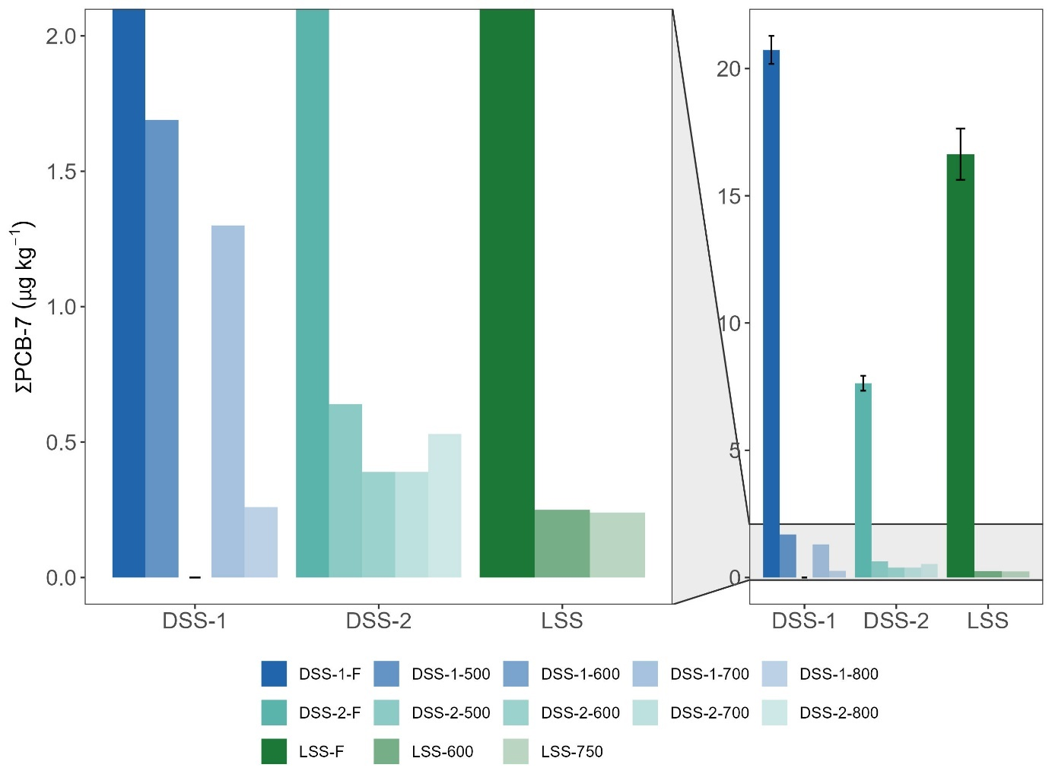

Figure 2 Total PCB-7 concentrations (µg kg-1) before and after pyrolysis treatment at increasing temperatures for the different feedstocks tested.

### PAHs in biochars

Only four samples were below the European Biochar Certificate threshold for premium quality biochar of <4 mg kg-1 for PAH-16: WT-500, LSS-750, LSS-600 and DSS-1-800. 14 of 23 biochar samples were below the EBC basic quality threshold of 12 mg kg-1.

**Sewage sludge and food waste reject biochars.** The concentration of ∑PAH-16 in the sewage sludge biochars (SS-BCs) ranged from 0.38-37 mg kg-1 (Figure 3, Table S.X). The distribution of PAHs in the SS-BCs was similar for the four SSFs and mainly dominated by Nap (36-72%) and Phen (10-27%).

**Wood-based biochars.** The highest PAH-16 concentrations overall were found for waste timber (WT) where WT-600 contained 118 ± 5 mg kg-1 ∑PAH-16. %). The highest PAH-concentration in garden waste (GW) was found for GW-600 (14 ± 1 mg g-1). The distribution of PAHs in WT and GW was similar and mainly dominated by Flt (34 and 25%), Phen (10 and 28%), Pyr (22 and 17 %) (Figure S.X).

**Food waste reject biochar.** PAH-16 in FWR was 0.39 ± 0.01 µg g-1 (0.02 ± 0.1 µg TE g-1). The distribution of PAHs in FWR (Figure S.X) was dominated by Phen, Pyr and Flt (27, 19, and 17%, respectively), similar to the SSFs and WBFs.

Sørmo et al. (2020) reported a PAH-16 concentration of 14 ± 5 mg kg-1 for waste timber pyrolyzed at 700 ˚C in a medium-scale Pyreg 500 unit. Mean ∑PAH-16 concentration for all temperatures and feedstocks was 16 mg kg-1 and median was 7 mg kg-1 for…

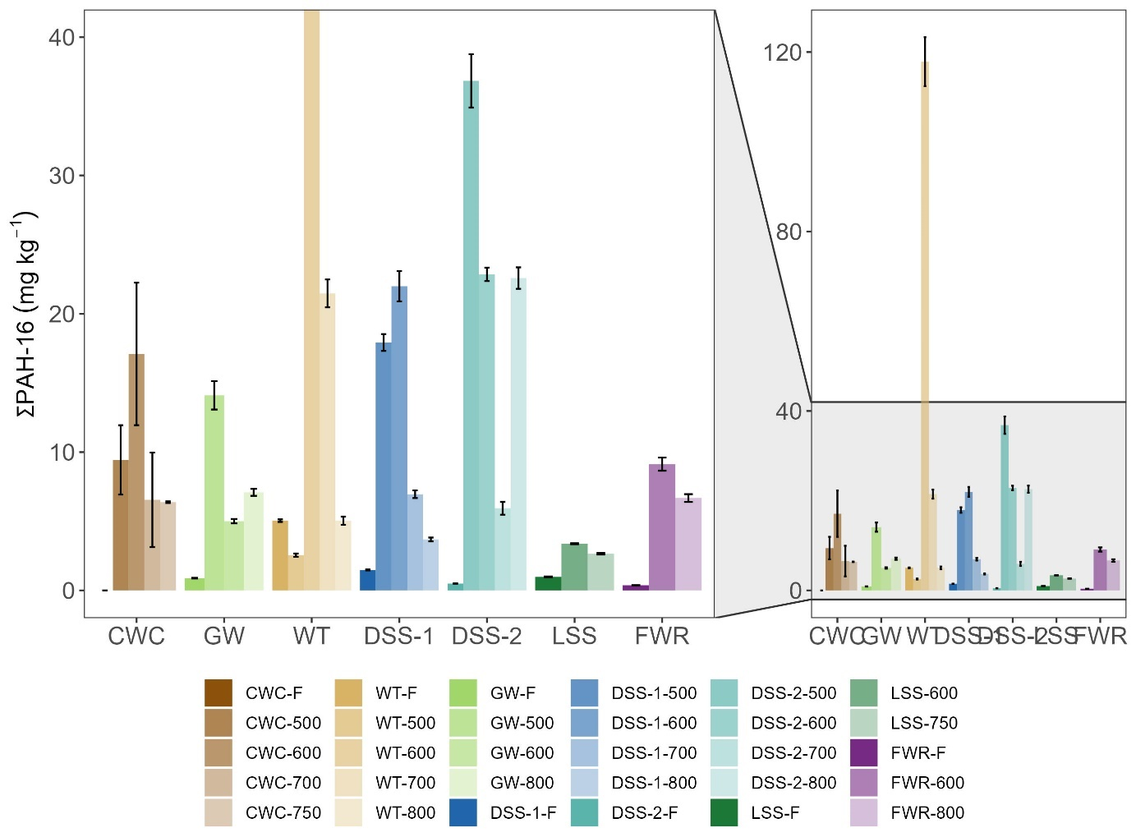

Figure 3 Total PAH-16 concentrations (mg kg-1) before and after pyrolysis treatment at increasing temperatures for the different feedstocks tested.

## Removal efficiencies

Removal efficiencies (RE) for ∑PCB-7 and ∑PCDD/PCDF-17 were >99.9% across all pyrolysis temperatures and feedstocks (Table 2). Thus, a pyrolysis temperature of 500 ˚C is likely sufficient to remove nearly 100% of PCBs and dioxins in sewage sludge feedstocks.

Note that RE (Eq. 1) is corrected for biochar yield to account for mass reduction (yields are provided in the SI of Sørmo et al., n.d.).

Table 2. Removal efficiency % (RE) of PCB-7 and PCDD/PCDF-17 in TEQ by pyrolysis of waste feedstocks at temperatures 500-800 °C normalized for yield biochar.

|  |  |  |  |
| --- | --- | --- | --- |
| **Feedstock** | **Pyr. temp. (˚C)** | **% RE** | |
| **∑PCB-7** | **∑PCDD/PCDF-17 (TEQ)** |
| DSS-1 | 500 | 99.9747 | 99.9875 |
| 600 | 99.9463 | 99.9865 |
| 700 | 99.9678 | 99.9857 |
| 800 | 99.9506 | 99.9868 |
| DSS-2 | 500 | 99.9385 | 99.9564 |
| 600 | 99.9253 | 99.9481 |
| 700 | 99.9406 | 99.9579 |
| 800 | 99.9404 | 99.9551 |
| FWR | 600 | n.d. | 99.9432 |
| 800 | n.d. | 99.9590 |
| LSS | 600 | 99.9675 | n.d. |
| 750 | 99.9724 | n.d. |

n.d. = pollutant not determined in biochar sample.

## Emission factors

Organic pollutant emission concentrations (EC), emission factors (EF), and distribution of pollutants between the particle and gas phase for each feedstock and treatment temperature are presented in Table 3.

### Emission factors dioxins

EFs for dioxins ranged from <LOQ to 0.45 µg TEQ tonne-1 and emission concentrations (EC) ranged from <LOQ to 41 pg m-3. Dioxins were primarily detected in the particle phase—77-100% of the total dioxins in the exhaust were associated with particles.

Emission concentrations of TCDD/Fs were 2-3 orders of magnitude lower than the EU emission standard (0.1 ng I-TEQ Nm−3) (Paradiz & Dilara, 2003).

### Emission factors PAHs

EFs for PAH-16 ranged from 4.7 to 30699 mg tonne-1 (Table 3). Sørmo pyreg-700 emission factor for WT-700: 20 ± 0.2 mg tonne-1 was similar to EF in this study was 26 mg tonne-1 (Sørmo et al., 2020). Emission concentration WT-700-Pyreg: 0.18 ± 0.03 µg m-3. The gas phase fraction was 43 ± 22% compared to 100% gaseous in this study. Clean wood was significantly higher EF than WT. satisfy premium or basic European Biochar Certificate criteria? PAHs were primarily detected in the gas phase—70-100% of the total PAHs in the exhaust were emitted as gas.

Table 3 Emission concentrations (EC) and emission factors (EF) of PAH-16 and PCDD/F-17 and the respective toxic equivalents (TEQ) detected in flue gas from the pyrolysis of sewage sludge (DSS-1, DSS-2, LSS), wood-based feedstocks (WT, GW, and CWC) and reject (FWR) pyrolyzed at the temperatures specified, along with the relative fractions of ∑PAH-16 and ∑PCDD/F-17 found in the gaseous and particle-based fractions (%). The values are normalized to per kg biochar produced.

|  |  |  |  |  |  |  |  |  |  |  |  |  |  |  |  |  |  |  |  |  |
| --- | --- | --- | --- | --- | --- | --- | --- | --- | --- | --- | --- | --- | --- | --- | --- | --- | --- | --- | --- | --- |
| ***PAH-16*** | | | | | | | | | | | | | | | | | | | | |
|  | **DSS-1** | | | **DSS-2** | | | | **FWR** | | **LSS** | | **WT** | | | | **CWC** | | | **GW** | |
|  | **500** | **600** | **700** | **500** | **600** | **700** | **800** | **600** | **800** | **600** | **750** | **500** | **600** | **700** | **800** | **500** | **600** | **700** | **500** | **800** |
| **EC (µg m-3)** | 0.31 | 0.22 | 137 | 1.7 | 3.2 | 1.6 | 421 | 21 | 2.4 | 5.1 | 2.3 | 1.4 | 0.27 | 0.41 | 2.0 | 5.9 | 0.2 | 0.4 | 25.8 | 4.5 |
| **EC TEQ (µg m-3)** | 0.0003 | 0.0002 | 1.9 | 0.002 | 0.01 | 0.003 | 3.7 | 0.07 | 0.01 | 0.03 | 0.003 | 0.01 | 0.0004 | 0.0005 | 0.010 | 0.02 | 0.0002 | 0.0004 | 0.09 | 0.02 |
| **EF (mg tonne-1)** | 203 | 69 | 30699 | 13 | 32 | 11 | 5288 | 1221 | 58 | 164 | 100 | 78 | 11 | 26 | 42 | 1738 | 4.7 | 18 | 2356 | 356 |
| **EF TEQ (mg tonne-1)** | 0.20 | 0.07 | 31 | 0.01 | 0.03 | 0.01 | 5.3 | 1.2 | 0.06 | 0.16 | 0.10 | 0.08 | 0.01 | 0.03 | 0.04 | 1.7 | 0.005 | 0.02 | 2.4 | 0.4 |
| **Particles (%)** | 7 | 14 | 30 | 0 | 0 | 0 | 14 | 16 | 5 | 6 | 17 | 12 | 0 | 0 | 14 | 6 | 16 | 2 | 10 | 11 |
| **Gaseous (%)** | 93 | 86 | 70 | 100 | 100 | 100 | 86 | 84 | 95 | 94 | 83 | 88 | 100 | 100 | 86 | 94 | 84 | 98 | 90 | 89 |
| ***PCDD/F-17*** | | | | | | | | | | | |  |  |  |  |  |  |  |  |  |
|  | **DSS-1** | | | **DSS-2** | | | | **FWR** | | **LSS** | |  |  |  |  |  |  |  |  |  |
|  | **500** | **600** | **700** | **500** | **600** | **700** | **800** | **600** | **800** | **600** | **750** |  |  |  |  |  |  |  |  |  |
| **EC (pg m-3)** | <LOQ | <LOQ | <LOQ | 41 | 13 | 3.1 | 38 | <LOQ | 16 | 1.3 | 21 |  |  |  |  |  |  |  |
| **EC TEQ (pg m-3)** | <LOQ | <LOQ | <LOQ | 2.7 | 0.6 | 0.15 | 2.2 | <LOQ | 1.6 | 0.10 | 1.5 |  | |  |  |  |  |  |  |  |
| **EF (µg tonne-1)** | <LOQ | <LOQ | <LOQ | 0.52 | 0.75 | 0.08 | 1.2 | <LOQ | 0.90 | 0.03 | 6.2 |  | |  |  |  |  |  |  |  |
| **EF TEQ (µg tonne-1)** | <LOQ | <LOQ | <LOQ | 0.03 | 0.04 | 0.004 | 0.07 | <LOQ | 0.09 | 0.002 | 0.45 |  | |  |  |  |  |  |  |  |
| **Particles (%)** | <LOQ | <LOQ | <LOQ | 100 | 100 | 100 | 100 | <LOQ | 77 | 100 | 86 |  | |  |  |  |  |  |  |  |
| **Gaseous (%)** | <LOQ | <LOQ | <LOQ | 0 | 0 | 0 | 0 | <LOQ | 23 | 0 | 14 |  | |  |  |  |  |  |  |  |

## Distribution of PAHs in pyrolysis products

Table 4 shows how the produced PAHs is distributed between the different pyrolysis products for wood chips (CWC) and digested sewage sludge 1 (DSS-1) at different temperatures. For CWC and DSS-1, >99% of ∑PAH-16 end up in the pyrolysis oil and less than 0.06% is emitted as exhaust (gas and particles). Only 0.06-1.34 % end up in the biochar. This shows that the technical adjustments to the Biogreen pyrolysis units with a negative pressure inside the pyrolysis chamber continuously draw flue gases out of the chamber and condenses in the condensing units and ends up in the oil. For all samples except DSS-1-700, ∑PAH-16 in biochar is below or equivalent to the EBC premium quality biochar criteria (<4 mg kg-1) (EBC, 2022).

Table 4 Distribution of ∑PAH-16 in biochar, pyrolysis oil, and exhaust (particles and gas) in total concentration (mg kg-1) and percent distribution. The distribution is normalized to the amount of feedstock used to produce the corresponding product fractions.

|  |  |  |  |  |  |  |  |  |  |  |
| --- | --- | --- | --- | --- | --- | --- | --- | --- | --- | --- |
|  |  | **∑PAH-16 concentration (mg kg-1)** | | | | | **% ∑PAH-16 distribution** | | | |
| **Feedstock** | **Pyr. temp. (˚C)** | **biochar** | **oil** | **particle** | **gas** | **total** | **biochar** | **oil** | **particle** | **gas** |
| CWC | 500 | 2 | 2381 | 0.0002 | 0.003 | 2383 | 0.07 % | 99.93 % | 0.00001 % | 0.0001 % |
| 600 | 3 | 2627 | 0.0003 | 0.002 | 2630 | 0.13 % | 99.87 % | 0.00001 % | 0.0001 % |
| 700 | 1 | 2204 | 0.4 | 0.9 | 2206 | 0.06 % | 99.88 % | 0.02 % | 0.04 % |
| DSS-1 | 600 | 13 | 946 | <LOQ | 0.003 | 959 | 1.34 % | 98.66 % | <LOQ | 0.0003 % |
| 700 | 4 | 801 | <LOQ | 0.001 | 806 | 0.54 % | 99.46 % | <LOQ | 0.0001 % |

# Conclusions

We conclude that…

Supporting Information

Supplementary data associated with this article can be found here x.

Acknowledgements

The authors acknowledge funding from the Research Council of Norway, mainly through the joint-industry sustainability (BIA-X) project “Valorization of Organic Waste” (VOW) (NFR 299070) whereof Lindum AS (stakeholder in sorbent application), the Norwegian Geotechnical Institute (research institute and project leader), and Scanship (technology supplier) played the key roles for generating the test material and data for this manuscript.

References

EBC. (2022). European Biochar Certificate - Guidelines for a Sustainable Production of Biochar. *Carbon Standards International (CSI), Frick, Switzerland*, *10.2*.

Hu, Z., Nomura, N., Kong, H., Wijesekara, S., & Matsumura, M. (2007). Changes in Chlorinated Organic Pollutants and Heavy Metal Content of Sediments during Pyrolysis (7 pp). *Environmental Science and Pollution Research-International*, *14*, 12–18.

Huygens, D., Saveyn, H., Tonini, D., Eder, P., & Delgado Sancho, L. (2019). Technical proposals for selected new fertilising materials under the Fertilising Products Regulation (Regulation (EU) 2019/1009). *FeHPO CaHPO*, *4*.

Moško, J., Pohořelý, M., Cajthaml, T., Jeremiáš, M., Robles-Aguilar, A. A., Skoblia, S., Beňo, Z., Innemanová, P., Linhartová, L., & Michalíková, K. (2021). Effect of pyrolysis temperature on removal of organic pollutants present in anaerobically stabilized sewage sludge. *Chemosphere*, *265*, 129082.

Paradiz, B., & Dilara, P. (2003). *Dioxin emissions in the candidate countries: Sources, emission inventories, reduction policies and measures*.

Paulsrud, B., Wien, A., & Nedland, K. T. (1997). *A survey of toxic organics in Norwegian sewage sludge compost and manure*.

Sørmo, E., Castro, G., Hubert, M., Licul-Kucera, V., Quintanilla, M., Asimakopoulos, A. G., Cornelissen, G., & Arp, H. P. H. (n.d.). The Decomposition and Emission Factors of a Wide Range of Pfas in Diverse, Contaminated Organic Waste Fractions Undergoing Dry Pyrolysis. *Contaminated Organic Waste Fractions Undergoing Dry Pyrolysis*.

Sørmo, E., Silvani, L., Thune, G., Gerber, H., Schmidt, H. P., Smebye, A. B., & Cornelissen, G. (2020). Waste timber pyrolysis in a medium-scale unit: Emission budgets and biochar quality. *Science of the Total Environment*, *718*, 137335.